Brooklyn torah gazette
For parshas ha’azinu 5780
Volume 4, Issue 5 (Whole Number 157) 15-23 Tishrei 5780/ October 12, 2019
Printed L’illuy nishmas Nechama bas R’ Noach, a”h

For a free subscription, please forward your request to keren18@juno.com

Recapturing the Unique
Yom Tov Thoughts of
Rav Avigdor Miller
By Daniel Keren

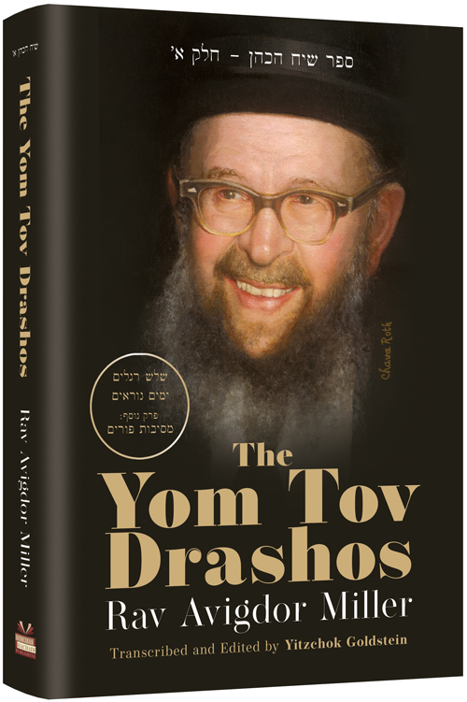

(“The Yom Tov Drashos [of] Rav Avigdor Miller,” Transcribed and Edited by Yitzchok Goldstein, with cover art by Mrs. Chava Roth, 372 pages, Simchas Hachaim Publishing and distributed by ArtScroll, 2019)
Eighteen years after his petirah, the Torah legacy of Rav Avigdor Miller (1908-2001), zt”l, grows ever stronger, perhaps even greater than when the American-born Marbitz HaTorah was alive. During his lifetime, in addition to being a Mashgiach Ruchani (spiritual guide) at Yeshiva Rabbi Chaim Berlin and a pulpit rabbi in Chelsea, Massachusetts and Brooklyn, New York; Rav Miller authored a dozen English-language seforim (books) on hashkafah (Jewish philosophy), history and commentary on the Chumash.
Perhaps even more influential were his more than 1,200 taped lectures of his Thursday night hashkafah shiurim that were recorded in his small Brooklyn shul on Ocean Parkway in Flatbush (Congregation Bais Yisroel of Rugby, also known as the Bais Yisroel Torah Center.)

Amazing Stories about Dramatically
Transforming Hundreds of Lives
During Rav Miller’s lifetime those tapes managed to reach tens of thousands of English-speaking Jews in communities throughout the world. Amazing stories abound about how many hundreds of secular assimilated Jews turned their lives around dramatically after a “chance” encounter with one of his books or by listening to a tape someone else offered them.
Today all of his books are still available for purchase in Jewish bookstores and his tapes can be obtained by contacting the Simchas Hachaim Publishing, a project of Yeshiva Gedolah Bais Yisroel whose rosh hayeshiva is Rabbi Shmuel Miller, the son of Rav Avigdor Miller who loyally continues the legacy of his world famous father.
Also in the years after Rav Miller was nifter, more than a dozen books have been published that focus on various aspects of his Torah legacy. The most recent volume is the work of a devoted talmid – Reb Yitzchok Goldstein who has been a member of Rav Miller’s shul going back to when it was still in the East Flatbush section of Brooklyn in the early 1970s and who continues to daven in the synagogue on Ocean Parkway that is now guided by Rabbi Miller’s illustrious grandson, Rabbi Eliyahu Zev Brog.

Creating a Stronger Kesher to Hakodesh Baruch Hu
Reb Goldstein who was a public school teacher, would with the strong encouragement of his wife devote most of his evenings attending shiurim that Rav Miller delivered in his shul for the benefit of the mispallilim (congregants) in addition to taking part in all of the classes his spiritual mentor delivered on Shabbos and Sundays. And in this process his life was changed gradually but dramatically from that of a typical American Jew to a Yid striving to make a stronger kesher (connection) to not only his teacher but more importantly to Hakodesh Baruch Hu.
Beginning in the 1980’s Reb Goldstein began on Motzei Shabbos and Motzei Yom Tov to write from memory his notes of what his rebbe muvhak discussed on the parsha and the festival in notebooks. With Rav Miller’s encouragement he began preparing small booklets typed by his wife from his notes that he would distribute free of charge to members of the shul and to many others that would come to attend shiurim delivered by Rav Miller.
Reb Goldstein was not just a journalist writing an article on what he heard. He was a dedicated talmid (student) striving to capture the essence of what his primary teacher spoke about the parsha or festilval on Shabbos or Yom Tov mornings before the Mussaf service. If he had questions (and he had many), he would go to Rav Miller and get clarifications.
After ten years of privately publishing these booklets for free distribution in the shul, many readers began suggesting that he have the booklets published in book form for the benefit of many thousands of readers who didn’t have access to picking up copies in the shul. And with the encouragement of Rabbi Shmuel Miller and the assistance of Reb Aryeh Narrows, the director of Simchas Hachaim Publishing, work was done over the past few years that has now resulted in a magnificent sefer that brilliantly captures the spirit of Rav Miller on our major Jewish holidays.

Accurately Capturing the Essence of His Rebbe Muvhak
As one who was privileged to hear Rav Miller speak on both Shabbos and Yom Tov as well as other occasions, I can verify that Reb Goldstein has accurately captured the essence of what his rebbe muvhak tried to tell and inspire his mispallilim. I am sure that in Gan Eden, Rav Miller must be rejoicing over this important sefer that will surely help new generations of English-speaking Jews gain a Slobodka mussar view of how a Jew should celebrate a Yom Tov.
This new book – “The Yom Tov Drashos [of] Rav Avigdor Miller” is divided into five sections – Pesach, Shavuos, Rosh Hashanah, Yom Kippur and Sukkos that were the result of the diligent notes written after the Yom Tovim by Reb Goldstein. A special bonus chapter offering Rav Miller’s insights into the holiday of Purim that were given at his famous Purim mesibos (parties) in the shul was made possible by tape recordings made by Rabbi Shemuel Chamoula, z”l, another legendary talmid of Rav Miller.
So if you fondly remember Rav Miller or you have only heard about his incredible contributions to the revitalization of American Jewry in the second half of the 20th Century, you will undoubted want to read “The Yom Tov Drashos [of] Rav Avigdor Miller.” It can be found in Jewish bookstores or by contacting the publisher by calling (718) 258-7400 or clicking www.simchapub.com or emailing info@simchashachaim.com

Reprinted from this week’s edition of The Jewish Connection.

Rav Avigdor Miller On Impeachment and Fake News

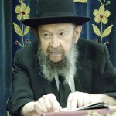

QUESTION: Did you change your mind about President Nixon now that it has been proven that he cheated on his income taxes?
ANSWER: If anybody is even a little bit acquainted with the income tax laws, he knows that they have so many nuances of interpretation, that if you get a mean judge, he could convict almost anybody of income tax evasion on technicalities. And that's besides the fact that he could actually convict most people outright for straight out fraud. If investigations were made on everybody, most people would be behind bars. This is well-known.
What are accountants for? Not to give the government it’s due. An accountant is there to see how much he can keep out of the hands of the government. But even when an accountant is perfectly honest and his report doesn't hold back anything, still there are so many shades of meaning in the tax codes.
You know that many of these cases have gone in front of the courts. Income tax cases are constantly coming up in front of the Supreme Court, which means that the laws are open to interpretation. One court says this and then it's overturned. And then it's appealed and it's overturned again.
Nixon didn't cheat on his income taxes. He had some of the best accountants in the country, you can be sure of that. And their interpretation was one way. But once these eagle-eyes hawk liberals are after him, so anything that he does is interpreted to his discredit. And therefore they forced him to pay. He could have fought it in the courts. Absolutely he could have fought this case in the courts. But he didn't want to. It wasn't worth it. That's why he paid.
Now, on the subject of the tapes, we have to realize that America is actually running wild. To take tapes of a president's private conversations and to broadcast them on the radio for everyone to hear — that means that America has hit a new low. Never before has there been such a disgrace.
And therefore, we have to keep our heads above water. There is a flood of wickedness that is sweeping the country. And it's a craze. It's not a rational thing. Just because the Democrats couldn't win at the ballot box, they're trying to recoup their losses in Congress through impeachment.
On this subject, you have to know that the public are nothing but the victims of the media. I have told you many times that you are all the victims of the radio and the newspapers. But if we were able to judge the situation impartially, you'd see that President Nixon is actually one of the great presidents. He is a victim of persecution.
And I think that every Jew should speak up. Every Jew should take his cue, not from the mischievous men on the radio and television, but he should take his cue from the Gedolei Yisroel, and he should be מתפלל בשלומה של מלכות. You should pray for the welfare of the President and his government.
I think we all ought to write a little note to President Nixon. Address it to President Nixon, White House, Washington D.C. and write: "President Nixon, we are with you." And put the date on it so that he shouldn't think that it was a week ago that you wrote it. No, you're writing it today, after the news came out. "President Nixon, we are with you!" And if you can also write some other notes to his opponents, telling them what to do, then do it. And if you want to tell them where to go, you can do that too.

Reprinted from the October 3, 2019 email of Toras Avigdor, based on Tape #59 (April 1974).

Rabbi Berel Wein
On Parshas Ha’azinu

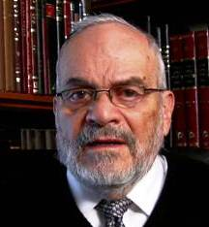

Our great teacher Moshe, in his concluding hymn regarding the future of the Jewish people, calls as his witnesses heaven and earth. These witnesses are, in human terms, eternal and omnipresent. They will always be there to testify that Moshe concluded a binding covenant between G-d and Israel, and that this covenant is a symbol of eternity and destiny.
Heaven and earth represent the physical world and the changing, yet seemingly unending nature of the planet that we inhabit. King Solomon taught us that all things human are subject to change and subject to new circumstances, but that the earth and its natural forces implanted within it from the moment of original creation, always remain the same.
One of the lessons that can easily be derived from this is how puny our strength is, in comparison to the forces of nature. Volcanoes, hurricanes, earthquakes, rains and drought are all part of regular occurrences in our lives and have been from the beginning of human existence.
To this extent, human beings are always tempting fate, since we are always so vulnerable regarding these great natural forces. Operating beyond our control, and many times even beyond a minimum of our understanding, they are certainly beyond our ability to exactly predict when and if they will occur and affect our lives. Clearly, Moshe could not have found better witnesses that would bind us to our covenant than those which cannot be affected by us and are not subject to our pressures or influences.
The hymn on this week's Torah reading has been taught, over the centuries, to Jewish children and fixed in their memory bank. It is these words that haunt all Jewish history and create that feeling of angst and uncertainty that so characterizes the Jewish personality, especially in our time.
The Jewish world today has far more physical riches and ostensible security than it ever has had, over the past numerous centuries. Yet, it appears that a sizable portion of the Jewish world is not happy with themselves, with the Jewish state, and, certainly, not with the Jewish religion and its Torah.
There appears to be a continuing and gnawing frustration and feeling of dissatisfaction that is present in our society, no matter how great our material blessings and social successes are. This lack of satisfaction is directly traceable to the words of the hymn that is the centerpiece of this week's Torah reading.
Moshe guaranteed that this hymn, like the entire Torah itself, would never be forgotten, and, could never be eliminated from the Jewish memory bank and psyche. Thus, like the eternity of the witnesses – heaven and earth – to our covenant, this song of destiny is also one of unity, and one that will always be remembered - even if the memory of it many times is only subconscious. It becomes the secret of Jewish survival, and the impetus that guides us forward, many times against our own will and conscious knowledge.

Reprinted from this week’s website of Rabbiwein.com

After Retirement: A New Stage, A New Chapter, A New Life

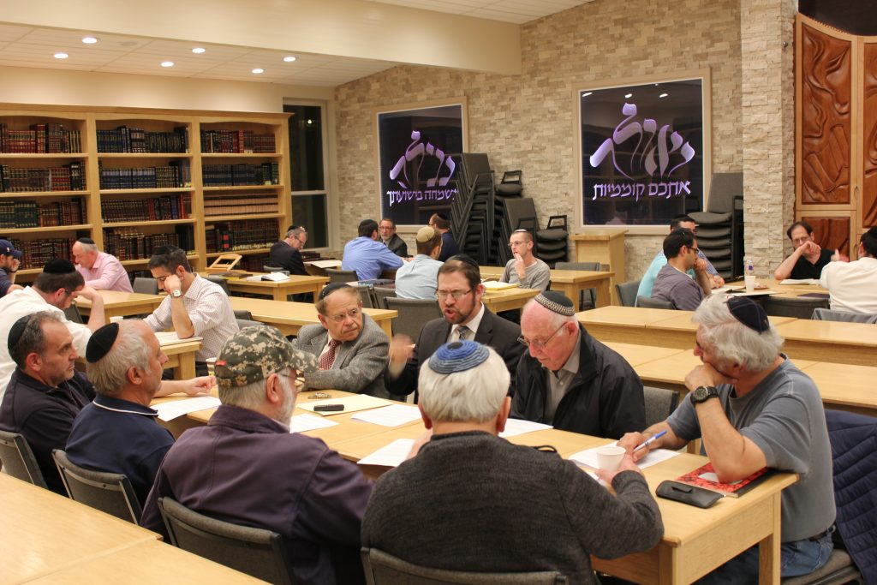
A group of retirees learning together at the Beis Midrash at the Cooper Yeshiva High School for Boys. Courtesy of Rabbi Braha

Nowadays, retirement is not an end but a new beginning, an opportunity for seniors to reinvent themselves
Decades ago, many seniors would move to South Florida to passively live out their twilight years,” says Rabbi Efrem Goldberg, whose shul, the Boca Raton Synagogue, boasts a significant senior population along with a growing membership spanning all ages. “Nowadays, we find seniors moving here to write the next active chapter of their lives.”
Indeed, as the senior population grows—due to longer life expectancy and the Baby Boomer generation aging—for many seniors, retirement has become an opportunity to grow and develop in new and exciting ways.
In the Orthodox community, this transition stage often means devoting oneself to intense Torah study. In fact, in communities throughout the country, a veritable explosion of Torah learning has developed around retirees.
“Many seniors are realizing that playing mahjong or golf is not enough,” says Rabbi Goldberg. “They’re looking for something more to fill their days with meaning.”
Retiree kollelim have sprung up, especially in big cities with large frum senior populations, giving older adults—some of whom never had the opportunity to learn Torah in a serious fashion when they were younger—a chance to experience the joy and thrill of ongoing Torah study. Similarly, women who are no longer juggling career and childrearing are devoting their time to engage in high-level Torah learning.
Making a difference in their communities is another way retirees are finding fulfillment.
“Unlike generations ago, people today who are in their seventies don’t view themselves as elderly,” says Rabbi Goldberg, adding that with advances in medicine, older adults tend to be healthier and more active overall.
“Many empty nesters define the next stage of their lives with learning or volunteering or both,” he says. Indeed, with endless chesed opportunities available, ranging from preparing food packages to visiting the ill, seniors are tapping into their talents and strengths and finding ways to give back. In the pages ahead, you will find stories of a few men and women who are making their later years rich with personal growth, learning and chesed.

Robert Spitz
By Steve Lipman
Robert Spitz says he was “very nervous” the first time he went to Memorial Sloan Kettering Cancer Center sixteen years ago. He was neither a patient at the famed treatment and research hospital in Manhattan, nor accompanying a friend or relative, but a volunteer to brighten the days of sick children.
The resident of Hillcrest, Queens, took early retirement from a successful job supplying paper goods to the food industry because he “wanted to make a difference.” He decided to help kids fighting cancer.
As a volunteer with the New York-based Chai Lifeline, Spitz, sixty-six, travels five days a week to Sloan Kettering and to several other local hospitals. There, the one-time “workaholic” spends several hours a day visiting young patients and their relatives, trying to bring some light into their otherwise dark days.

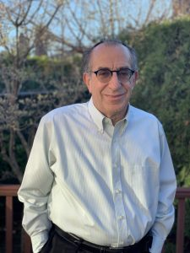
Robert Spitz

He had no training for this duty, hence his nervousness when he began his volunteer service.
Like all volunteers at the hospital, he had a brief orientation from Sloan Kettering and Chai Lifeline, but had no background in chaplaincy, counseling or medicine that would prepare him for dealing with people undergoing often-grueling procedures. Some of the youngsters, he realized, were terminally ill.
All he had, Spitz says, was his outgoing personality, his desire to help and his religious faith. In addition, he was fortunate to have the example of his wife, Dina, who has also served as a hospital volunteer.
“My wife gave me advice as well as a basic idea of what to expect when volunteering in the hospital,” he says. “More than anything else, it is important to realize that every day is different. As a volunteer, you are constantly meeting different people, children with different personalities. You try to relate to as many people as possible in all sorts of ways.”
Though Chai Lifeline primarily services Jewish children, Spitz talks with kids of any religious background in Sloan Kettering who need some morale boosting.
We volunteers do whatever is necessary to make the patients’ lives easier.
He talks with the children. He listens to them. He plays games with them. He tells a devar Torah. He buys them snacks when their restricted diets allow it. He dons gloves, a gown and a surgical mask when hospital protocol requires it. He takes their Hebrew names for a Mi Sheberach in shul.
“We volunteers do whatever is necessary to make the patients’ lives easier.”
Over time, Spitz forms “very warm” friendships with the children and their parents. Later, when the patients recuperate, he attends their bar mitzvahs and weddings. Sadly, if a child dies, he may at times attend the levayah. That part of his volunteering is “extremely upsetting.”
Though he’s done volunteer work for his congregation, the Young Israel of Hillcrest, for the YESS (Yeshivah Education for Special Students) program for Jewish children with learning disabilities and for Tomchei Shabbos, his heart is at Sloan Kettering.
He tells of an extremely ill thirteen-year-old boy who went to Disney World a few years ago; the trip was cut short when the boy’s condition deteriorated. Spitz figured the teen’s spirits would be low the next week. Instead, he says, the boy was beaming. “I had the greatest two days of my life,” he told Spitz.
That teen’s attitude changed Spitz’s life. “All he spoke about what was he had, not what he was missing. I don’t think I’ve complained about anything since.”
At Sloan Kettering, Spitz has learned about gratefulness. “When you do chesed,” he says, “you get so much in return.”

Reprinted from the Fall 2019 edition of Jewish Action, a publication of the Orthodox Union.

Demographic Shift:
Israeli Jewish Fertility Rate Tops Arab Rate, Hits 45-Year High
By David Rosenberg

Jewish fertility rate continues to rise as Muslim rate declines, Palestinian Authority fertility rate falls to parity with Israel's.

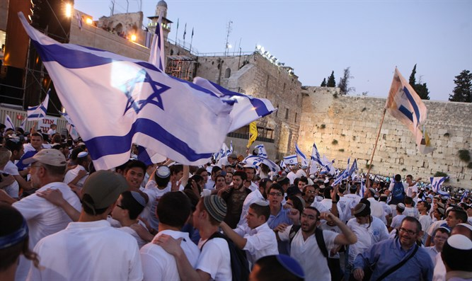
Israeli flags at the Western Wall in Jerusalem Photo credit - Flash 90

The demographic shift in Israel, marked by an increase in fertility rates among Jews and a decrease among Muslims, continued last year, as the total fertility rate for Jewish women hit a 45-year high.
According to data released by Israel’s Central Bureau of Statistics, the total fertility rate – that is, the average number of children a woman will have in her life time – for Jewish women in Israel rose in 2018 to 3.17, the highest level since the early 1970s, when the Jewish TFR averaged 3.28. In the 1990s, the Jewish TFR fell to its lowest level, averaging 2.62 both between 1990 to 1994 and 1995 to 1999.
The increase in the Israeli Jewish TFR in 2018 was smaller than in previous years, rising only 0.01 from the 3.16 total fertility rate in 2017.
The rise was fueled primarily by an increase in the number of women in older age groups having children, which offset a decline among younger women. While the general fertility rate – the number of women per 1,000 who gave birth - among teenagers aged 15 to 19 fell from 4.2 to 3.9 and also fell among women in their early 20s from 89.0 to 88.0, every age cohort 25 and up saw an increase.
Jewish women ages 25 to 29 had a general fertility rate of 176.0 in 2018, compared to 174.4 the year before, while women ages 30-34 had a GFR of 201.1, compared to 200.8 in 2017.
Christian and Druze women also saw an increase in their total fertility rates, though both remain far below the Jewish rate. Christian women – including both Arab Christians and Christian immigrants who moved to Israel with Jewish relatives – saw their TFR rise from 1.93 in 2017 to 2.06 in 2018. The Druze total fertility rate rose from 2.10 to 2.16.
But birthrates declined for both Muslim women in Israel and women not registered with any religious group, with the latter group’s total fertility rate falling from 1.58 to 1.54.
Muslim women still had the highest total fertility rate in 2018 at 3.20, despite falling from 3.37 the year before. Among Israeli Arabs as a whole, however, the TFR fell in 2018 to 3.04 – below the Jewish TFR of 3.17. The 3.20 TFR marks the lowest level recorded among Muslim Arab women in Israel, who fifty years ago had on average six more children than Jewish women (TFR 9.22 vs 3.3.6).
In raw numbers, the number of children born to Jewish mothers increased in 2018 to 135,809, or 73.7% of the 184,370 total live births in Israel. In 2017, Jewish mothers gave birth to 134,630 children, or 73.3% of the total number of live births. In 2010, Jewish women accounted for 72.6% of all live births, with 120,673 children born. In 2000, births to Jewish women made up just 67.4% of all live births in Israel, with 91,936 children born to Jewish mothers.
By comparison, the number of births to Arab women (Muslim, Christian, or Druze) fell in 2018 to 43,268, down from 43,782 in 2017. Births to Arab women made up 23.5% of all live births in Israel in 2018, compared to 23.8% in 2017, 24.5% in 2010, and 29.9% in 2000.
Within the Jewish population, families with a father born in the Americas had the highest birthrate, with a total fertility rate of 4.17. Families where the father was born in Israel had the second highest TFR at 3.34, compared to 3.05 for families which had a father born in Asia, 3.03 for families with the father born in Africa, and 3.02 for those where the father was born in Europe.
When broken down by region, the highest total fertility rate in Israel was reported among women living in Judea and Samaria, at 4.89, followed by the Jerusalem district at 3.97, southern Israel at 3.59, the central district at 2.78, northern Israel at 2.68, the Tel Aviv area at 2.63, and the Haifa district last at 2.52.
The rising Israeli Jewish fertility rate has also pulled into near-parity with that of Judea and Samaria, which according to the CIA World Fact Book 2019 had a TFR of 3.2, compared to a TFR of 3.27 in 2017. The Gaza Strip, however, has a significantly higher fertility rate, at 3.97. This also marks a significant decline compared to 2017, when the Gaza TFR was 4.13.
Commenting on the Central Bureau of Statistics report, demographer and former Israeli diplomat Yoram Ettinger said that the numbers disproved the “myth of an Arab demographic time bomb” in Israel.
“Demographers of doom who have reverberated Palestinian data without examination, have ignored reality, promoting the myth of an ‘Arab demographic time bomb.’ They have been dramatically mistaken or outrageously misleading,” Ettinger wrote in The Ettinger Report.
Citing reports which suggest the Palestinian Authority’s population figures have significantly over-counted the number of Arabs living in Judea, Samaria, and Gaza, Ettinger claimed that there is a nearly two-thirds majority of Jews between the Jordan and the Mediterranean if the Gaza Strip is not included.
“Well-documented data – rather than subjective assessments or projections – confirm a 65.5% Jewish majority in the combined area of Judea, Samaria and pre-1967 Israel, benefitting from a tail wind of fertility and migration, in addition to a potential Aliyah (immigration) wave of 500,000 Jews from France, Britain, the former USSR, Germany, Argentina, etc.”

Reprinted from the October 4, 2019 email of Arutz Sheva.

